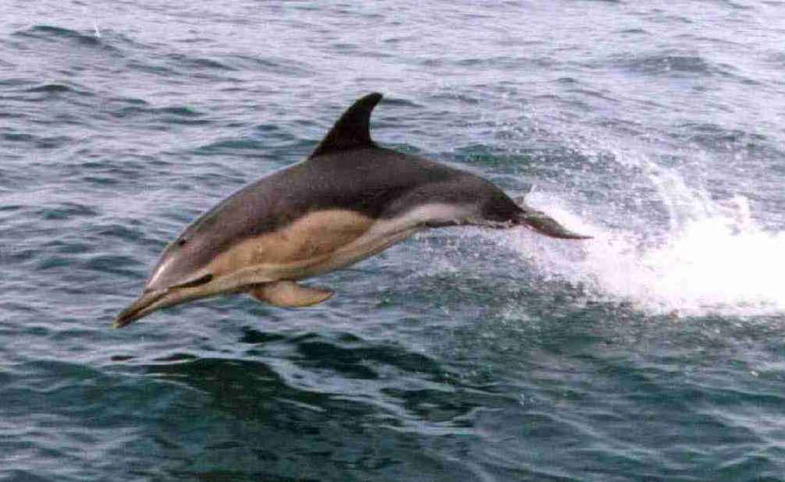
Carolyn Barton - MMO training

PSO TRAINING COURSE – REGISTRATION FORM

Name*:

Country of residence*:
e-mail address*:
Data protection*:  (please delete bold wording as appropriate) | I do/ do not consent to my name being included on the course register  I do/ do not consent to my e-mail address being included on the course register  I do/ do not consent to certificate verification checks being provided for third parties (e.g. employers) on request
* = required. By completing this form you are agreeing to the Terms and Conditions as detailed overleaf and at https://carolynbarton.co.uk/terms-and-conditions.html.

COURSE SUMMARY: For those working in a mitigation role in the offshore industries in the US Gulf of Mexico and US Atlantic. Topics include: marine mammals and sea turtles; sound in the seas; US legislation; activities requiring mitigation; geophysical survey mitigation protocols; vessel strike avoidance and reporting injured/dead species; explosive removal of structures; offshore wind energy developments; visual monitoring; introduction to passive acoustic monitoring; working as a PSO; life at sea; species identification.

COURSE DELIVERY: Online, self-navigated at your own pace. Downloadable resources included.

ASSESSMENT: Exam (multiple choice and drag-and-drop questions), 80% pass mark. Certificate awarded on completion (study of all pages and satisfactory completion of the exam).

YOU WLL NEED: Good understanding of the English language. Laptop/ PC/ tablet/ smartphone (landscape orientation recommended for phones) with compatible web browser, recommended browsers are the latest versions of the following:
Desktop and laptop computers: Mobile phones and tablets:
Google Chrome (Windows/Mac) Google Chrome (Android)
Mozilla Firefox (Windows/Mac) Mozilla Firefox (Android)
Microsoft Edge (Windows) Apple Safari (iOS)

Apple Safari (Mac)

COST: £180 per person (£162 student/recent graduate – proof required)

HOW TO ENROL: Complete this form and return to info@carolynbarton.co.uk. You will be sent a Paypal invoice for payment of the course fee – following payment you will receive a link to access the course (please allow up to 24 hours). Access to the course is available for 12 months (continued access is available on payment of a small annual fee).
Terms and Conditions:
Access to the training course is subject to payment of the course fee beforehand. On payment of the fee you will receive an enrollment email allowing you to access the course – please allow up to 24 hours for the enrollment email to arrive.
A refund is only available if you change your mind within 14 days of payment of the fee and if you have not started the course (i.e. have not accessed it). Any application for a refund must be made in writing or via e-mail. The fee is non-refundable once the course has been started (accessed) or if 14 days have elapsed since payment of the fee.
It is the responsibility of the trainee to ensure that the course content is appropriate for their needs by referring to the content as described on the web site (see footer below for web site address).
It is the responsibility of trainees to provide a device with a good internet connection and a compatible browser for viewing the course.
Enrollment gives you access to the course for 12 months; whilst every effort will be made to allow uninterrupted access to your course, this cannot be guaranteed. Access can be extended beyond 12 months on payment of a small annual fee, to be determined each year.
Trainees will not be registered as having completed a training course, nor will certificates be issued, until full payment is received, the course has been completed (all pages studied over an appropriate time period) and the exam passed. Learner analytics will be used to assess whether sufficient time has been spent studying the course. Please allow up to 7 days after course completion to receive your certificate, although you will usually receive it sooner. Lost certificates can be replaced free of charge. Please note that once a certificate has been issued, if during any period of enrollment (including extended enrollment) you require your certificate to be updated with a later date (e.g. as evidence of retraining) that this will require the course and exam to be repeated and payment of a recertification fee.
PSOs working in the US require approval from the National Marine Fisheries Service (NMFS); training is only part of the requirements for approval as a PSO, certain qualifications and experience are also required. It is the responsibility of the trainee to establish what the criteria for approval are (guidance is available at https://www.fisheries.noaa.gov/national/endangered-species-conservation/protected-species-observers) and to ensure that they meet these criteria should approval be sought. Carolyn Barton accepts no responsibility for anyone who completes the PSO course but is unable to gain approval from NMFS for work as a PSO. Carolyn Barton cannot be held responsible for any government or regulator updates in future that might require trainees to undergo further or additional training or meet additional criteria to gain approval for work as a PSO.
Carolyn Barton reserves the right to refuse enrollment on any training course.
Places on courses are not transferable and may not be sold to anyone.
It is assumed that the person who has registered is the person who has completed the course. Carolyn Barton reserves the right to withhold certificates if it is discovered that another person has done any part of the course.
Carolyn Barton does not give any warranty that the website or software is free from viruses or anything else that may cause harm and accepts no responsibility for the content or use of any other websites that you may access via links from the course.
Every effort has been made to ensure the material presented during the course is complete and accurate. However, Carolyn Barton cannot be held legally responsible for any errors, omissions or misinterpretations of the material. Carolyn Barton will not be liable for any direct, indirect, incidental, consequential or other loss or damages of any kind resulting in any way from the use or misuse of the material.
Course material is copyrighted and all rights are reserved; Carolyn Barton retains the title and intellectual property rights to the course. No material shall be copied, reproduced in any way, or distributed without prior written permission from Carolyn Barton. Files in the course Resources may be downloaded for non-commercial personal use only.
The course is regularly updated to reflect current practice - course content is therefore subject to change without notice.
These terms and conditions can be updated by Carolyn Barton at any time.
This agreement shall be governed by and construed in accordance with Scottish law and each party agrees to submit to the exclusive jurisdiction of the courts of Scotland.

